Sci Fi U: Wonderfest 2003
Scratchbuilding with Foam Instructor: Joe Brown

The materials needed consist of foam, cutting tools, and shaping and finishing tools. Almost any type of Styrofoam will do (packing material, floral foam forms, or sheet insulation foam), and everything discussed here applies to all of them. We are going to concentrate primarily on the sheet insulation foam (the Dow Blue foam and the Owens Corning Pink Foamular sheets).

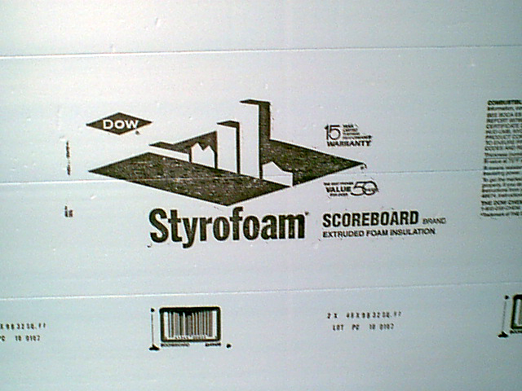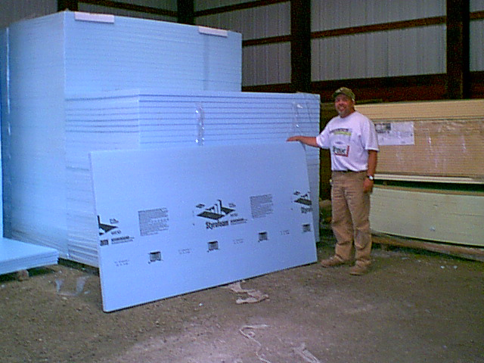

The pink or blue foam is a building construction insulation foam that is used for insulating walls and ceilings and when pouring foundations. Watch building sites, since they normally tear the foam off in large chunks and throw it away. It comes in various thicknesses. I use 2-inch foam for most work and ¼-inch foam for odds and ends. This foam comes in 8-foot by 4-foot sheets with perforations, so you can "snap" it into long sections. Have your lumber person cut the foam against the perforation twice, then you can snap sections from that. It can be purchased from home improvement stores such as Lowes or Home Depot. Many construction and lumber suppliers and building contractor supply companies have this material on hand.

Cutting Foam

Knives, including pocket knives, serrated knives, razors and razor cutters, and hot-wire cutters all work to cut foam, as do Dremel tools and machine shop tools.

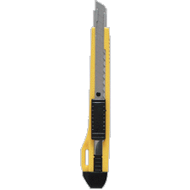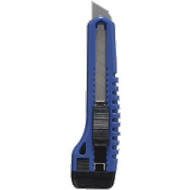

The basic idea is to cut the existing foam shape into one that closely approximates the desired final shape. Once that has been accomplished, it’s time for finishing the shape.

Hot-wire cutters can make extremely smooth, mess-free cuts in foam, but they can leave a crusted cutting surface. In most instances, they are well worth the money spent on them. Prices range from $2.95 for a small cutter from WalMart or from $30.00 for Woodland Scenics.

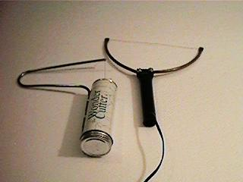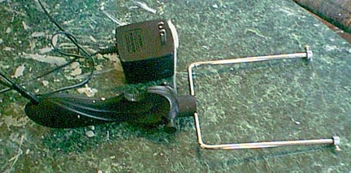

Of, you spend up to $100+ from specialty foam-cutter manufacturers (see below).



Personally, I find them well worth the money. But, you can even make your own hot-wire cutter! There are several websites that discuss this in great detail, so we will not cover that here.

Working the Foam

Working the foam with knives, razors, or hot-wire cutters is very easy to do. But, getting it to the precise shape that you have in mind is something that takes a bit of practice. Using sandpaper and sanding screens can make the work go very quickly, and it will make an astounding mess. Whenever possible, do sanding in an area that is easy to clean up (shag-carpeted rooms are a bad idea) or, better still, wet sand as much as you can. It won’t hurt the foam at all to be wet, and almost all of the “dust” from the foam stays in the water.
If you are using a blade instead of a hot-wire cutter, always run your blade through beeswax or even a regular candle before cutting the foam. This makes for a smooth cut, and it prevents the foam from ripping up on the blade. Whenever you can, use a hot-wire cutter (even the cheapie craft-style, battery-operated one at WalMart is better than NOT using a hot-wire cutter)!

Dave Merriman’s Dove construction article at Cult TVman’s website is something that really, really should be required reading when using foam as a master. (http://culttvman.com/scratchbuilding.html)

It’s true that Merriman always goes with the expensive stuff (Renshape Foam and the expensive version of Bondo filler), but it does do the job. I simply cannot afford to use those methods, but the techniques are very sound.

Finishing the Foam

Finishing tools (materials) consist of wire brushes, rasps, sanding screens for drywall, and sandpaper in a wide variety of grades.

The main goal here is to get the foam into the desired shape. Much of that can and should be done in the cutting stage. At this point, you are using the tools to get the foam ready for joining to any additional sections and for surface finishing. Shaping the foam can be done quickly and roughly with wire brushes and rasps. More controlled shaping is done with sanding screens and finer grades of sandpaper to get the shape of the part that you are making. I cannot over emphasize the convenience of wet sanding at this stage! Controlling the mess that shaping can cause will greatly add to having a good time working with this material.

Attaching the Foam

Joining materials include specific glues and mechanical joiners.

There are several choices for joiners available, and you should be consider each of them when you are planning a project. Poly Vinyl Acetate (PVA) glues are a traditional glue that still works well. I have used Weldbond on most of my larger foam models. This is a form of white glue that is similar to Elmers Glue. These glues are very safe to apply and form extremely durable bonds. Their main downside is the extended drying time, which can be up to two weeks! There is also a low-temp melt hot glue available. Slo-Zap CA glue is almost the only foam-safe SuperGlue that I know of.

I will often reinforce, or pin, a foam connection point with drywall screws. They apply easily and can hold a great deal of foam together. So yes, using screws on the foam is a viable option.

Surface Coatings

When it comes to successfully coating the foam, there are several choices. Alas, none of them are *perfect* choices, and what you are going to do with the model afterwards will be a factor (museum display piece, model show contender, fun model to goof off with, or master for a production run of kits). Whatever the planned end result is for the model will determine the best coating for it.

Surface coatings include a variety of materials, such as Bondo Filler putty, spackle, PVA glue (Elmers or other white glue), epoxy putties, and styrene. And fiberglass too! After the foam has been sanded into its final shape, I often cover it with acrylic spackle or Bondo Filler Putty. These are the more durable coatings. Glues with cover foam, and so will certain household acrylic enamel paints.

Spackle is cheaper and easier to work with, and it’s even kid-safe. Bondo is more durable/tougher, but it costs more and is a wee bit more toxic as a substance. Also, since Bondo sets up very fast, you need to work in sections. Both of the coatings above work well, and I use both, depending on my mood, budget, and the desired end result. If the model is purely for fun, I use the spackle. You can get an amazingly smooth finish with the spackle, and several of my models done that way have won awards at model shows. It’s just relatively fragile. My models have survived road trips and mucho handling, but the spackle can chip and crack over time. If it needs honest “rough-handling durability,” you need to be able to scribe it, or it will be used as a master to make more models with, Bondo is an excellent choice, as are the epoxy putties.

Yet another automotive product also works, Miracle Patch Muffler Repair Paste, which is made by Victor Products Des Plaines Illinois. It applies like a wet toothpaste, and it can be smoothed with a wetted finger. It takes about 8 hours to air-dry. It sands easily and takes paint well. And, it gives the foam a tough, rock-like shell! I could detect no fumes at all. It’s a silica-based paste that is designed to withstand high heat (mufflers get hot after all!). They do have a sanding dust caution on the package, but since I regularly wet-sand, that’s not an issue. It drills easily, but care is needed. Since it is silica-based, it’s very brittle, so a big factor is how thickly you have applied it.

There is also the option of using two-part epoxy resin to coat the model. This can be combined with fiberglassing the foam for very high strength.

Spackle. It is possible to use acrylic wall spackle to create an awesomely smooth surface. You just apply in a controllable area (from a size point of view). That means an area large enough that you are not doing this model for the rest of your life, but not so large that it dries out while you are working upon that section.

I have found that DAP Acrylic wall spackle can be found in BIG buckets at Home Depot and Lowes for cheap. More importantly, if you use a wetted finger (or other appropriate tool) to smooth it down while the spackle is still wet, that greatly (and I mean greatly!) reduces the sand–respackle–sand–respackle–sand treatment. But if you get it too wet, it never fully dries. That can be tricky to get down as a technique. The real advantages of spackle are that it’s cheap and can look awesome! But, it doesn’t scribe worth a dang, and it’s fragile after drying.
(http://culttvman.com/joe_brown_s_space_ghost_cruise.html)

Sheet Styrene. This can be tough to get to properly fit all the nooks and crannies, but as you well know, it scribes great, is fairly sturdy, and is fairly cheap. Andrew “Big Dog” Jackson has tried using the LePage’s Number 7 Green Contact cement with some success. He used it to bond sheet styrene to foam and says it worked really well. Just apply it, let it dry for an hour, then apply the sheet styrene. It bonds instantly, but it can still be peeled off for up to 24 hours if you don’t like the fit. I haven’t tried doing it that way, but I plan to very soon. There is also a new Liquid Nails adhesive (well, new to me) that is supposedly foam safe, and that’s on my experiment list.

Epoxy Putty. Now we are getting to the expensive options! For small models, I have had great success using plumbers putty and MagicSculpt (or Aves putty) to “hardcoat” a foam model. Just mix some up, roll it flat with a rolling pin, and drape it on the foam model. Done. It scribes well and is simple, effective, tough, and castable with room-temperature vulcanizing rubber. That's how I did my share of the masters for the Shrike model at the Starship Modeler store.
(http://www.picturetrail.com/gallery/view?p=999&gid=522865&uid=444676&members=1)

If it’s so good, you wonder why more folks don’t try doing that. Price, that’s why. The air-curing epoxy putties get expensive fast. Still, if you score a huge amount of MagicSculpt (or something similar), it’s worth considering.

Fiberglass. The horror! This is the technique used to make real-life surfboards that worldclass surfers depend on. And, many of the new (real airplane) private aircraft kits are insulation foam, covered by fiberglass and a coat of paint. If you ever catch the Discovery Wings Channel’s show A Plane Is Born, well, that’s how they do it. Fiberglass over foam.

It can be very hard to work with if you have no fiberglass experience, and it’s a health risk too. But, it is awesomely strong and very durable. A point to consider is to just using the two-part liquid epoxy to cover the foam, with no fiberglass. The various quick cure, two-part liquid epoxy glues work very well for giving the foam a tough surface. It scribes well, too!

Painting the Foam

Enamel paints will eat through Styrofoam, so I use either acrylic paints or I make sure that the entire model is completely covered with a surface barrier. After that is done, it is safe to use enamel paint. But, making sure that the entire surface of the foam is coated is the key to superb models from foam.

Foam is a really great modeling tool; it’s used by master modelers and professionals with amazing results. Try it!

All images in this document are copyright of their lawful owners.

